Bibliography

**Starting with the article title and newspaper name**

"Cruel and Unusual Punishments Before the Supreme Court." Editorial. *The New York*

*Times* 13 Oct. 2015: Web. 21 Feb. 2017. <https://www.nytimes.com/2015/10/14/opinion/cruel-and-unusual-punishments-before-the-supreme-court.html?_r=0>.

**Starting with the link>>>**

Board, The Editorial. "Cruel and Unusual Punishments Before the Supreme Court." *The*

*New York Times*. The New York Times, 13 Oct. 2015. Web. 21 Feb. 2017. <https://www.nytimes.com/2015/10/14/opinion/cruel-and-unusual-punishments-before-the-supreme-court.html>.

**Manually entered using article title, magazine title, print date, web address included**

Epps, Garrett. "The Death-Penalty Feud at the Supreme Court." *Atlantic* 13 Oct. 2015:

Web. 21 Feb. 2017. <https://www.theatlantic.com/politics/archive/2015/10/the-death-penalty-feud-at-the-supreme-court/410224/>

**Advice:**

**Unless ABSOLUTELY necessary, don’t use the internet link to create a citation on Easybib. Instead, use the following:**

1. **On the main Easybib page… Choose the option that BEST fits**

**your source. Usually: newspaper**

**article, magazine article, etc. Look**

**through all 59 OPTIONS.**

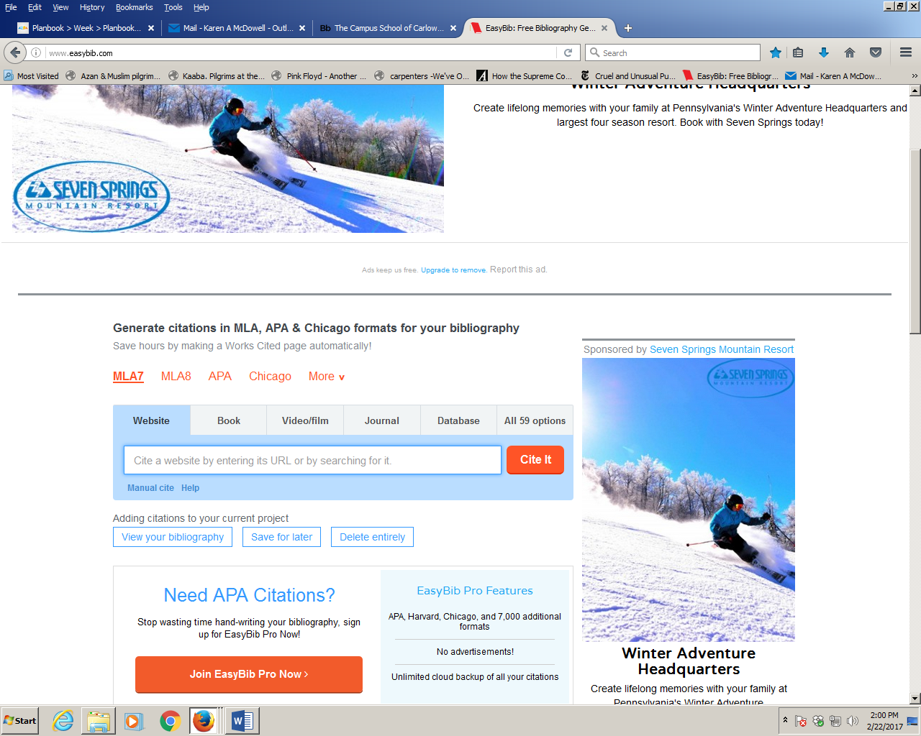

1. 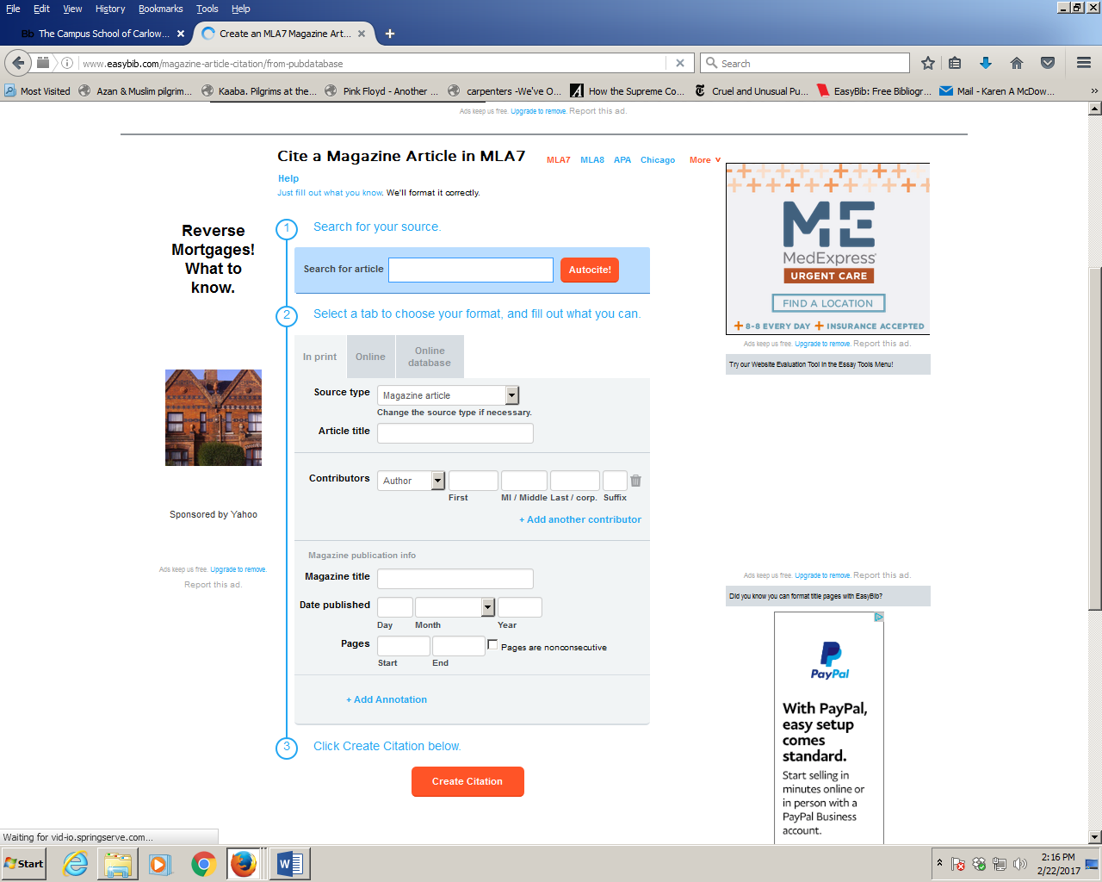**Use the TITLE of the article, not the link. Add as much info as you can manually, especially:**

**author, date, name of source…**